**PIZZA SALES SQL QUERIES**

**KPI**

1. **Total Revenue**

select sum(total_price) as total_revenue from pizza_sales

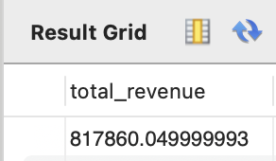

1. **Average Order Value**

select sum(total_price)/ count(distinct order_id) as average_order_value

from pizza_sales;

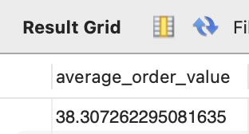

1. **Total Pizzas sold**

select sum(quantity) as total_pizzas_sold from pizza_sales;

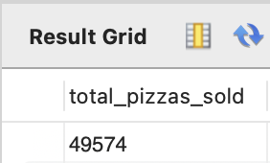

1. **Total Orders**

select count(distinct order_id) as total_orders from pizza_sales;

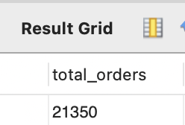

1. **Average Pizzas’ per order**

select sum(quantity)/count(distinct order_id) as avg_pizza_per_order

from pizza_sales;

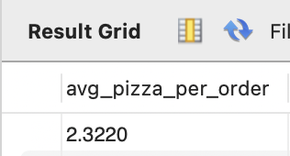

**Chart Requirements**

1. **Daily Trend for Total Orders**

select dayname(order_date) as order_day,

count(distinct order_id) as total_orders

from pizza_sales

group by dayname(order_date);

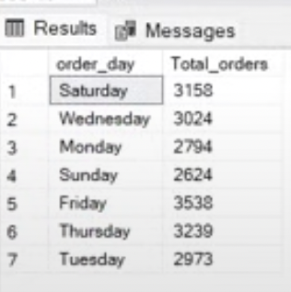

1. **Monthly trend for Total Orders**

Select dayofmonth(order_date) as month_name,

count(distinct order_id) as total_orders

From pizza_sales

Group by dayofmonth(order_date);

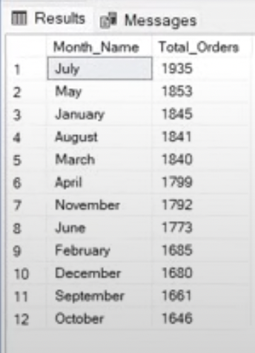

1. **Percentage of Sales by Pizza Category**

Select pizza_category, sum(total_price)*100/ (select sum(total_price) from pizza_sales) as sales_percentage

from pizza_sales

group by pizza_category

Order by sales_percentage;

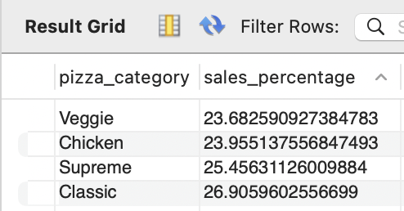

1. **Percentage of Sales by Pizza Size**

Select pizza_size, sum(total_price)*100/ (select sum(total_price) from pizza_sales) as sales_percentage

from pizza_sales

group by pizza_size

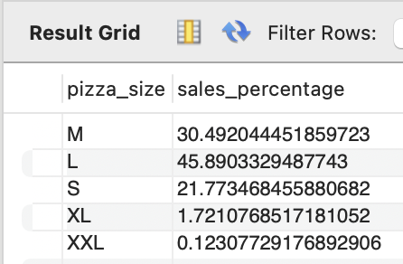

1. **Total Pizzas sold by pizza category**

Select pizza_category, sum(quantity) as total_pizza_sold

from pizza_sales

group by pizza_category

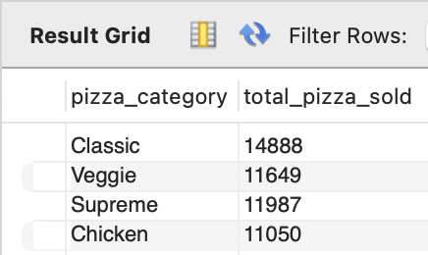

1. **Top 5 bestsellers by Total Pizzas Sold**

Select pizza_name, sum(quantity) as total_pizza_sold

from pizza_sales

group by pizza_name

order by sum(quantity) desc limit 5

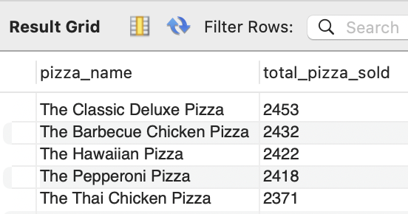

1. **Top 5 worst sellers by Total Pizzas Sold**

Select pizza_name, sum(quantity) as total_pizza_sold

from pizza_sales

group by pizza_name

order by sum(quantity) asc limit 5

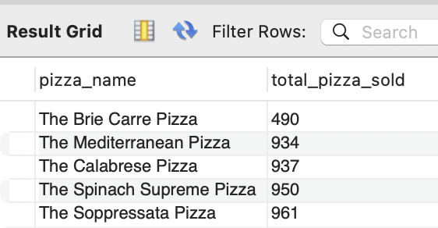

1. **Top 5 bestsellers by Revenue**

Select pizza_name, sum(total_price) as total_sales

from pizza_sales

group by pizza_name

order by sum(total_price) desc limit 5

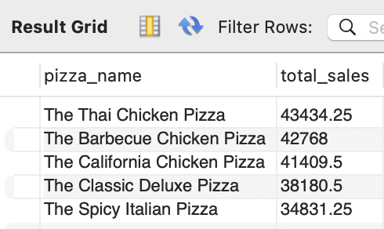

1. **Top 5 worst sellers by Revenue**

Select pizza_name, sum(total_price) as total_sales

from pizza_sales

group by pizza_name

order by sum(total_price) asc limit 5

